Comparison Of Effectiveness in Real-Time Ultrasound Guided Spinal Anaesthesia Versus Pre-Procedural Ultrasound Guided Spinal Anaesthesia in Obese Parturients: A Randomized Clinical Trial

Dr. Suman Hiremath1, Dr. Pratibha.S. D*2, Dr. Renuka Holyachi MD3, Dr. Shivanand.L. K4

1Dept of Anaesthesiology, BLDEDU Shri B M Patil Medical College, Vijayapura-586103, Karnataka, India

Email ID: [suman.1995.hiremath@gmail.com](mailto:suman.1995.hiremath@gmail.com)

2*Professor, Dept of Anaesthesiology, BLDEDU Shri B M Patil Medical College, Vijayapura-586103, Karnataka, India

Email ID: [pratibhakaradi@gmail.com](mailto:pratibhakaradi@gmail.com)

ORCID ID: 0000-0002-6528-1814

3Professor and HOD, Dept of Anaesthesiology, BLDEDU Shri B M Patil Medical College, Vijayapura-586103, Karnataka, India

Email ID: [renuka312@gmail.com](mailto:renuka312@gmail.com)

ORCID ID: 0000-0001-9265-4164

4Professor, Dept of Anaesthesiology, BLDEDU Shri B M Patil Medical College, Vijayapura-586103, Karnataka, India

Email ID: [Shivanandkarigar82@gmail.com](mailto:Shivanandkarigar82@gmail.com)

**\*Corresponding Author:**

Dr. Pratibha.S.D

Professor, Dept of Anaesthesiology, BLDEDU Shri B M Patil Medical College, Vijayapura-586103, Karnataka, India

Email ID: [pratibhakaradi@gmail.com](mailto:pratibhakaradi@gmail.com)

ORCID ID: 0000-0002-6528-1814

00Cite this paper as: Dr. Suman Hiremath, Dr. Pratibha.S. D, Dr. Renuka Holyachi MD, Dr. Shivanand.L. K, (2025) Comparison Of Effectiveness in Real-Time Ultrasound Guided Spinal Anaesthesia Versus Pre-Procedural Ultrasound Guided Spinal Anaesthesia in Obese Parturients: A Randomized Clinical Trial. *Journal of Neonatal Surgery*, 14 (22s), 482-488.

ABSTRACT

**Background:** The standard method for elective caesarean sections is spinal anaesthesia, however, in obese parturients, we may find it difficult to use conventional landmark-guided techniquesin identifying anatomical landmarks, leading to multiple attempts and increased risk of complications. Neuraxial ultrasound-guided (USG) techniques offer a promising solution by enhancing procedural accuracy and efficiency.

**Aim:** Aim of our study is to evaluate the efficacy of pre-procedural ultrasound-guided (PPUS) and real-time ultrasound-guided (RUS) spinal anaesthesia in obese parturients undergoing elective caesarean sections.

**Materials and Methods:** A total of 80 obese parturients (BMI >30 kg/m2, ASA II-III) scheduled for elective cesarean sections were randomized into two groups: Group RUS and Group PPUS. Primary outcomes includes the number of attempts, needle passes, and time taken for successful dural puncture. Secondary outcomes includes intervertebral space identification time, successful analgesia time and hemodynamic stability. Statistical analysis was performed using SPSS v20 with p< 0.05 considered significant.

**Results:** Attempts and needle passes were significantly less in Group RUS than in Group PPUS. In Group RUS, the average time for both successful lumbar puncture and intervertebral space identification was less.

**Conclusion:** Both RUS and PPUS techniques are effective for spinal anesthesia in obese parturients. However, RUS was significantly better technique in decreasing the number of attempts, needle passes, and procedural time, making it a more efficient and precise approach.

**Keywords:** *Spinal anesthesia, Obese parturient, Real-time ultrasound, Pre-procedural ultrasound , cesarean section , Neauraxial ultrasound*

1. Introduction

Spinal anaesthesia is the preferred technique for elective cesarean sections, commonly performed using a "blind" approach guided by surface landmarks. However, identifying these landmarks can be challenging in obese parturients, often resulting in multiple attempts. Such repeated attempts are associated with higher probability of complications, including paraesthesia, spinal haematoma, and post-dural puncture headache. In obese parturients, the manual palpation technique becomes particularly difficult due to the obscured bony landmarks.[1] Preprocedural neuraxial ultrasound-guided (USG) assessment offers a promising solution by improving spinal anaesthesia performance and reducing the number of attempts required in this high-risk population.[2,3]

Obesity is becoming more common among pregnant women, with studies indicating maternal obesity rates ranging from 20% to 35% worldwide, which makes spinal anaesthesia in this population an escalating challenge. The pre-procedural neuraxial ultrasound technique has emerged as an effective method for performing spinal anaesthesia by accurately delineating spinal anatomy and facilitating successful needle insertion.[3,4] Routinely , the anatomical landmark-guided method has been used to locate the subarachnoid space however, this approach can be unreliable in patients who are obese, who have edema in the lumbar region or anatomical variations, often resulting in incorrect identification of lumbar interspaces. Multiple needle insertion attempts not only increase patient discomfort and stress but also increases the risk of neuronal damage.[1,5]Neuraxial ultrasound blockade is a rather new advancement in regional anaesthesia as it addresses these challenges by providing a precise and reliable assessment of spinal anatomy. In pre-procedural USG- guided technique needle is inserted blindly after confirming the surface anatomical landmarks as compared to Real time ultrasound (RUS) image accusation of the spinal needle which seems to be a more efficient and preferred option.[6]

Real-time ultrasound (RUS) facilitates precise identification of the needle insertion site and trajectory for spinal anaesthesia. However, no studies have directly compared the efficiency of RUS-guided spinal anaesthesia with pre-procedural ultrasound (PPUS)-guided spinal anaesthesia in obese parturients. Ultrasound-guided techniques not only enhance procedural success but also play a crucial role in training environments, assisting novice anaesthesiologists in gaining proficiency in administering spinal anaesthesia.[4,7,8]

Obese parturients face a heightened risk of complications during spinal anaesthesia because of anatomical alterations, excess adipose tissue, and difficulties in achieving proper positioning, highlighting the importance of adopting more effective methods such as RUS and PPUS. Our study aims to evaluate and compare these two modalities by assessing primary variables, including the number of attempts, needle passes, and time required for successful dural puncture. Secondary variables include the median time to identify the intervertebral space, achieve successful analgesia, and a complete lumbar puncture. A failed lumbar puncture will be defined as the absence of CSF fluid.

1. Materials & Methods

This was a randomized clinal study conducted at a tertiary care teaching hospital. The Institutional ethical committee approval was obtained { BLDE(DU)/IEC/957/2023-24 } The study was registered under the clinical trial registry of India –CTRI/2023/10/059026 .A written consent was obtained from all patients after explaining the study protocol. Study was done on obese parturients aged 18-35yrs undergoing elective cesarean sections with ASA grade II and III were included in the study. Patients undergoing emergency C-section, any contraindication for spinal anaesthesia and history of lumbar spinal disease, lumbar surgery, uncontrolled hypertension and diabetes were excluded. From the study. Pre anaesthetic evaluation was done previous day of surgery which included general physical examination, vital parameters(Heart rate,, NIBP, oxygen saturation) BMI, detailed examination of spine, airway assessment by Mallampatti grading . Procedure regarding spinal anaesthesia was explained to the patients . Routine investigation was done ( Complete blood count, Fasting blood glucose, ECG, HIV, HbsAg, Urine routine, HbA1c.) and chest X-ray if required.

Patients were kept nill orally for 8hrs overnight. Patients were selected for the study based on the inclusion and exclusion criteria. Group RUS participants received procedural USG guided paramedian spinal anaesthesia, and Group PPUS received pre-procedural USG guided para median spinal anaesthesia.

Basal vital parameters were recorded in the preoperative room. Intravenous line was secured. Patients were monitored with heart rate, NIBP, oxygen saturation and electrocardiogram (ECG). All patients in Group RUS were placed on a level table with the help of an assistant. Under strict aseptic precautions, a 2% lignocaine local infiltration was administered while the L3-L4/L4-L5 level was used for the dural puncture. In both the groups, a 25G Quincke’s needle was used to inject about 2ml of hyperbaric bupivacaine 0.5% with adjuvant 60mcg of buprenorphine intrathecally.

Sterile conditions are maintained by placing a transparent sheet over the ultrasound machine and using the 2-5Mhz curvilinear probe. The L3-L4 and L4-L5 interspinous spaces were identified in the Group PPUS using ultrasound, with the parasagittal oblique (PSO) view providing the best imaging of the anterior complex (ligamentum flavum dura complex, or LFD) and the posterior complex (posterior longitudinal ligament, or PLL). The probe was positioned at these specific interspaces to get a crisp ultrasonic image. The midpoints of the probe's long and short borders were then marked with a skin marker. The midpoint of the line drawn between the two short border midpoints of the probe served as an insertion point for the spinal needle, and it was at the same horizontal level as the midpoint of the probe's long border.Using these points as guides, spinal anaesthesia was administered in the operating theatre.

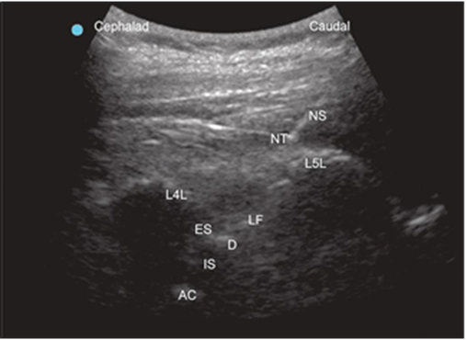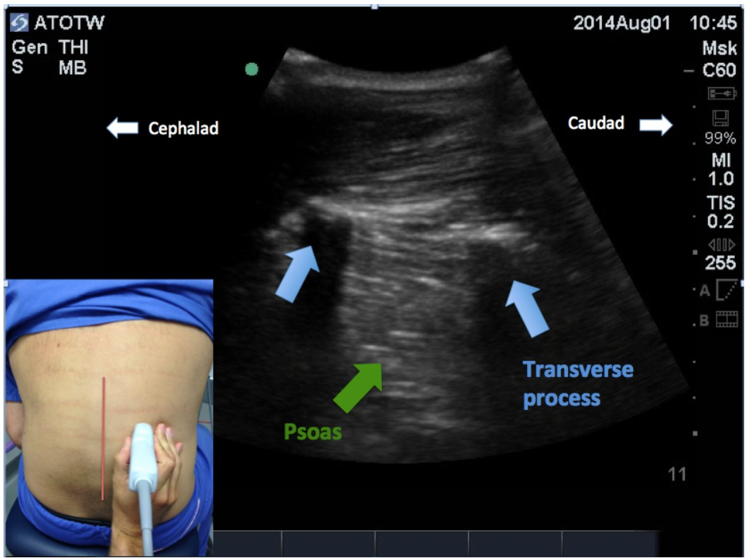

**A**

**B**

Fig.1 : A) Performing PPUS , B) US image showing spinal needle insertion (real‑time) in the paramedian oblique view with needle directed towards the L4-L5 inter-laminar space.

NS: needle shaft, NT: needle tip, L4L: L4 Lamina, L5L: L5 lamina: LF: ligamentum flavum, ES: epidural space; D: Dura,IS: intrathecal space, AC: anterior complex 11

Using real-time images in PSO view, L3-L4, L4-L5, and the interspinous space were identified in the Group RUS, and the needle's entry into the spinal canal was visualised. Once the sacrum was identified as the starting component, the probe was advanced cephalad with a 20° tilt towards the midline. Next, the target gap between L3-L4 and L5-S1 as well as the lumbar lamina were identified. The probe was then further rotated 25° towards the midline to obtain a conventional oblique parasagittal approach. In addition to facilitating the visualization of the lamina, intervertebral space, and posterior longitudinal ligament complex, this perspective also allows for the more ergonomic manipulation of the needle and probe simultaneously. In order to puncture the ligamentum flavum/dura slowly, needle was introduced into the interlaminar space where we start to get "the typical giveaway feeling." Throughout the process, the patient's vitals were assessed. Patients symptoms of nausea, vertigo, vomiting, and pruritis were evaluated. Hypotension and bradycardia was treated as per standard protocol.

SAMPLE SIZE :

The The required minimum sample size is 40, within in each group to identify a real difference in Means between two groups, with a 90% power and a 5% (two-sided) level of significance.

The anticipated Mean ±SD of pre-procedural USG guided group will be 78.35±58, and the real time USG guided group 38.19±28 resp[11]



$Z_{∝}$ Level of significance=95%

$Z_{β}$--power of the study=90%

d=clinically significant difference between two parameters

SD= Common standard deviation

Total sample size is 80

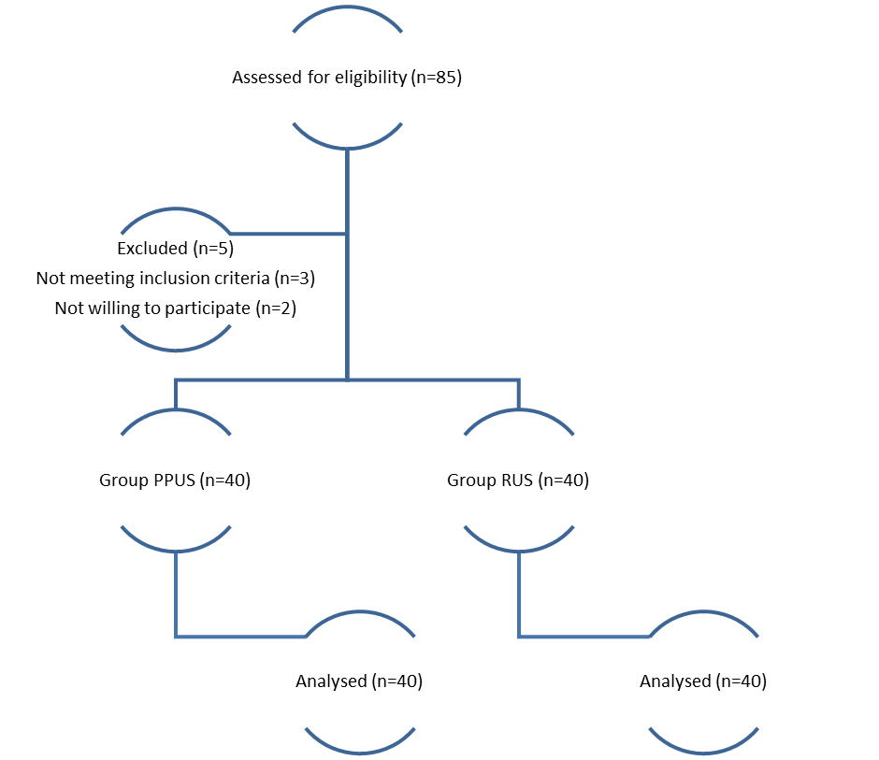

Fig 2: Consort diagram

**STATISTICAL ANALYSIS:**

The data obtained were entered into a Microsoft Excel sheet, and statistical analysis was performed using a statistical analysis was performed using SPSS Version 23.0. Mean ±SD, Median, IQR, counts, percentages, and graphs were used to obtain the results. The independent t test was utilised to compare continuous variables that were normally distributed across two groups; the Mann Whitney U test was employed for variables that were not normally distributed. The Chi-square test was utilised to compare categorical variables between the two groups. A p-value of less than 0.05 was considered statistically significant.

1. RESULTS

Our study included total of 80 patients with 40 patients in each group. The mean age, mean weight, mean height, ASA grading and BMI between the two groups was comparable with no statistical significant difference (Table 1). The number of attempts were significantly lower in Group RUS (3±2.4) compared to Group PPUS (6±3.2). Number of needle pass were significantly lower in Group RUS (5±2.9) compared to Group PPUS (10±6.7)(Table 3)

Table 1 : Demographic data

|  |  |  |  |
| --- | --- | --- | --- |
|  | Group RUS | Group PPUS | p value |
|  | Mean±SD | Mean±SD |  |
| Age in years | 24.9±3.2 | 25.4±3.3 | 0.473 |
| Height in cm | 153.9±4.8 | 154.4±5.9 | 0.69 |
| Weight in kg | 85.8±6.4 | 85.4±4.6 | 0.749 |
| BMI | 34.9±2.6 | 35.5±3 | 0.342 |

There is significant longer duration of time taken to identify the spaces in Group PPUS (86±25.2) compared to Group RUS (52±17.5). Similarly, there is significant longer duration of time taken for successful lumbar puncture in Group PPUS (298±28.7) compared to Group RUS (276±33.4). (p<0.05) Success rate was found to be similar 100 percent in both the groups.

There is a significant less number of attempts in Group RUS compared to Group PPUS .(p<0.05) majority were with 2nd and 3rd attempt in Group RUS compared to the 5th to 6th attempts in Group PPUS . Similarly the number of needle passes was found to be significantly lower in Group RUS compared to Group PPUS .(p<0.05) .Majority of cases needed the 3-5 number of needle pass in Group RUS in comparison to the 8-10 number of needle pass in Group PPUS(Table 3)

Table 2 : Comparison of mean heart rate and MAP

|  |  |  |  |
| --- | --- | --- | --- |
|  | Group RUS | Group PPUS | p value |
|  | Mean± SD | Mean± SD |  |
| Mean HR rpm | 78.1±7.0 | 78.6±9.2 | 0.78 |
| MAP mmhg | 76.2±6.6 | 78.1±8.0 | 0.24 |

Table 3 : Comparison of various parameters between groups

|  |  |  |  |
| --- | --- | --- | --- |
|  | Group RUS | Group PPUS | p value |
|  | Mean±SD | Mean±SD |  |
| Time taken to identify space | 52±17.5 | 86±25.2 | <0.001* |
| Number of needle passes | 5±2.9 | 10±6.7 | <0.001* |
| Number of attempts | 3±2.4 | 6±3.2 | <0.001* |
| Time taken for successful lumbar puncture | 276±33.4 | 298±28.7 | 0.005 |

1. Discussion

Given the growing prevalence of maternal obesity and the challenges it presents for spinal anesthesia, it is essential to determine which ultrasound technique offers greater efficacy, efficiency, and safety in this high-risk population.[9,10] This study aims to compare RUS and PPUS in terms of procedural success, number of attempts, needle passes, time taken for dural puncture, and overall feasibility in obese parturients undergoing elective cesarean section.

Present study included total of 80 patients with 40 patients in each group. The mean age between the group was comparable with no significant difference. The mean age in Group PPUS was 25.4yrs and Group RUS was 24.9yrs.(p>0.05) The ASA grade distribution was found to be comparable between the groups, with no noticeable difference noted. The mean heart rate and MAP were found to be comparable between the groups. Similar to present study Ravi PR et al., documented with comparable mean age of patients between the groups with mean age of 55.5yrs in PUS group and 58.5yrs in Group RUS, with no significant difference in gender distribution between the groups. [11] In similar study by Chen L et al., the mean age, gender distribution, ASA grades and physical characters such as height, weight and BMI were comparable between both the groups.[12]

There is significant less number of attempts in Group RUS compared to Group PPUS .(p<0.05) majority were with 2nd and 3rd attempt in Group RUS compared to the 5 to 6 attempts in Group PPUS . Similarly the Number of needle passes was found to be significantly lower in Group RUS compared to Group PPUS .(p<0.05) Majority of cases needed the 3-5 number of needle pass in Group RUS in comparison to the 8-10 number of needle pass in Group PPUS(Table 3) In concordance to present study Ravi PR et al., documented with better outcomes in Group RUS compared to the PUS group with median number of attempts of 2 (IQR 1–2) versus 4 (IQR 2–4) (P< 0.001). Additionally, the Group RUS required fewer passes, less time to identify the space, and shorter time for successful lumbar puncture compared to the PUS group. Overall, the Group PUS exhibited longer times and higher attempts for these procedures, highlighting the efficiency of the RUS approach. The success rate documented in their study was 98% in PUS group and 92.5% in Group RUS.[11] In study by Park SK et al., the ultrasound assisted approach achieved a significant fewer needle pass, higher first pass and first attempt success rate.[13] Also in study by Chen L et al., documented number of attempts and median pass were significantly lower in ultrasound assisted spinal anaesthesia compared to the Real time US guided anaesthesia.[12]

Another study by Uyel Y et al., the first-attempt success rate for accessing the subarachnoid space was notably higher in the ultrasound group (74.4% vs. 53.8%, p = 0.008). Patients in the ultrasound group also required fewer needle insertion attempts (median 1 vs. 2, p = 0.038) and redirections (median 2 vs. 3, p = 0.028) compared to the landmark-guided group. However, no significant differences were observed between the groups regarding total procedure time, pain scores, patient satisfaction, or complications.[14] Also, Mengzhu L et al., found that the ultrasound group demonstrated a considerably higher first-attempt success rate, fewer cases requiring more than 10 needle passes, fewer puncture attempts, shorter procedure times (including needle site identification), and higher patient satisfaction scores compared to the landmark group. However, for patients with BMI 30–34.9 kg/m², there were no significant differences in first-attempt success rates or procedure times, except for longer needle site identification time in the ultrasound group. These findings suggest that ultrasound guidance is particularly advantageous for patients with higher BMI, enhancing procedural efficiency and success while improving patient experience.[15]

Also in study by Dhanger S et al., the number of attempts needed to perform a lumbar puncture on a pregnant patient was shown to be a much lower when pre-procedural ultrasound was used instead of the standard landmark technique is what the study found.[16] There is significant longer duration of time taken to identify the spaces in Group PPUS (52±17.5) compared to Group RUS (86±25.2) Similarly ,there is significant longer duration of time taken for successful lumbar puncture in Group PPUS (298±28.7) compared to Group RUS (276±33.4). (p<0.05) (Table 3) Success rate was found to be similar 100 percent in both the groups. Ravi PR et al., al Group RUS compared to PUS group.[11] Chen L et al., documented with significant shorter locating time in Group RUS, however there was significant longer procedure time and total time in Group RUS.[12]

In concordance to present study Narkhede HH et al., documented with the ultrasound-guided (UG) group demonstrated a significantly higher rate of successful dural puncture on the first needle insertion attempt (90% vs. 50%, P < 0.05) in contrast to the anatomical-guided (AG) group. The mean number of needle passes was significantly lower in the UG group (1.07 vs. 1.90, P < 0.05), and only 3.3% of UG patients required more than three midline attempts. Procedure time was notably shorter in the UG group (2.25 minutes vs. 4.35 minutes), while VAS scores for pain were comparable between groups. These findings underscore the value of preprocedural ultrasound imaging in facilitating central neuraxial blockade, particularly in elderly patients with challenging anatomical landmarks.[17] From a clinical perspective, these findings support the growing adoption of real-time ultrasound guidance in obstetric anesthesia. While PPUS remains a viable option, RUS appears to offer significant advantages in terms of procedural ease and efficiency. Further research with larger sample sizes and multicenter trials could provide additional insights into optimizing neuraxial ultrasound techniques for high-risk obstetric populations.

Strengths: The findings of study showing significant strength tot the findings showing the real time US guidance as superior method.

Limitation: The few limitations include the small sample size, single centre study which reduce the strength to generalise to larger population. The further studies in larger sample size need to be conducted to strengthen the current findings of the study.

Conclusion: Both techniques demonstrated a 100% success rate, indicating their feasibility in this patient population. However, RUS guidance was significantly more efficient in terms of procedural ease and time. Patients in the Group RUS required fewer attempts and needle passes to achieve successful spinal anaesthesia compared to the Group PPUS, with the majority achieving success within one or two attempts. Overall, while both techniques are effective, real-time ultrasound guidance appears to be superior in decreasing the number of attempts, needle passes, and procedural duration, making it a more efficient approach for spinal anaesthesia in obese parturients.

**Funding**: Nil

**Conflict of interest**: Nil

**REFERENCES**

* 1. Chin KJ, Ramlogan R, Arzola C, Singh M, Chan V. The utility of ultrasound imaging in predicting ease of performance of spinal anesthesia in an orthopedic patient population. Reg Anesth Pain Med. 2013;38(1):34-38. doi:10.1097/AAP.0b013e3182734927
  2. Whitty R, Moore M, Macarthur A. Identification of the lumbar interspinous spaces: palpation versus ultrasound. Anesth Analg. 2008;106(2):538-540, table of contents. doi:10.1213/ane.0b013e31816069d9
  3. Chong SE, Mohd Nikman A, Saedah A, et al. Real-time ultrasound-guided paramedian spinal anaesthesia: evaluation of the efficacy and the success rate of single needle pass. Br J Anaesth. 2017;118(5):799-801. doi:10.1093/bja/aex108
  4. Conroy PH, Luyet C, McCartney CJ, McHardy PG. Real-time ultrasound-guided spinal anaesthesia: a prospective observational study of a new approach. Anesthesiol Res Pract. 2013;2013:525818. doi:10.1155/2013/525818
  5. Ekinci M, Alici HA, Ahiskalioglu A, et al. The use of ultrasound in planned cesarean delivery under spinal anesthesia for patients having nonprominent anatomic landmarks. J Clin Anesth. 2017;37:82-85. doi:10.1016/j.jclinane.2016.10.014
  6. Arzola C, Davies S, Rofaeel A, Carvalho JCA. Ultrasound using the transverse approach to the lumbar spine provides reliable landmarks for labor epidurals. Anesth Analg. 2007;104(5):1188-1192, tables of contents. doi:10.1213/01.ane.0000250912.66057.41
  7. Park SK, Yoo S, Kim WH, Lim YJ, Bahk JH, Kim JT. Ultrasound-assisted vs. landmark-guided paramedian spinal anaesthesia in the elderly. Eur J Anaesthesiol. 2019;36(10):763-771. doi:10.1097/EJA.0000000000001029
  8. Ansari T, Yousef A, El Gamassy A, Fayez M. Ultrasound-guided spinal anaesthesia in obstetrics: is there an advantage over the landmark technique in patients with easily palpable spines? Int J Obstet Anesth. 2014;23(3):213-216. doi:https://doi.org/10.1016/j.ijoa.2014.03.001
  9. Helayel PE, da Conceição DB, Meurer G, Swarovsky C, de Oliveira Filho GR. Evaluating the depth of the epidural space with the use of ultrasound. *Rev Bras* Anestesiol. 2010;60(4):376-382. doi:10.1016/S0034-7094(10)70046-5
  10. Neal JM, Brull R, Horn JL, et al. The Second American Society of Regional Anesthesia and Pain Medicine Evidence-Based Medicine Assessment of Ultrasound-Guided Regional Anesthesia: Executive Summary. Reg Anesth Pain Med. 2016;41(2):181-194. doi:10.1097/AAP.0000000000000331
  11. Ravi PR, Naik S, Joshi MC, Singh S. Real-time ultrasound-guided spinal anaesthesia vs pre–Procedural ultrasound-guided spinal anaesthesia in obese patients. Indian J Anaesth.2021;65(5):356-361. doi:doi: 10.4103/ija.IJA_446_20.
  12. Chen L, Huang J, Zhang Y, et al. Real-Time Ultrasound–Guided Versus Ultrasound-Assisted Spinal Anesthesia in Elderly Patients With Hip Fractures: A Randomized Controlled Trial. Anesth Analg. 2022;134(2):9-11. doi:DOI: 10.1213/ANE.0000000000005778
  13. Park SK, Cheun H, Kim YW, et al. Ultrasound-assisted spinal anesthesia: A randomized comparison between midline and paramedian approaches. J Clin Anesth. 2022;80:110823. doi:10.1016/j.jclinane.2022.110823
  14. Uyel Y, Kilicaslan A. Preprocedural Ultrasonography Versus Landmark-Guided Spinal Anesthesia in Geriatric Patients with Difficult Anatomy: A Prospective Randomized Trial. Eurasian J Med. 2021;53(1):9-14. doi:10.5152/eurasianjmed.2020.20215
  15. Li M, Ni X, Xu Z, et al. Ultrasound-assisted technology versus the conventional landmark location method in spinal anesthesia for cesarean delivery in obese parturients: a randomized controlled trial. Anesth Analg. 2019;129(1):155-161. doi:doi: 10.1213/ANE.0000000000003795.
  16. Dhanger S, Vinayagam S, Vaidhyanathan B, Rajesh I, Tripathy D. Comparison of landmark versus pre-procedural ultrasonography-assisted midline approach for identification of subarachnoid space in elective caesarean section: A randomised controlled trial. Indian J Anaesth. 2018;62(4):280. doi:10.4103/ija.IJA_488_17
  17. Narkhede HH, Kane D, Parekh V, Hemantkumar I. A cohort study of anatomical landmark-guided midline versus pre-procedure ultrasound-guided midline technique of spinal anesthesia in elderly patients undergoing orthopedic surgery. J Anaesthesiol Clin Pharmacol. 2019;35(4):522-527. doi:DOI: 10.4103/joacp.JOACP_396_17.