The Role of knowledge transfer mechanisms in enhancing the performance of manufacturing firms: a systematic literature review.
Zhang Jianjun¹, Abhijit Ghosh²
¹Research Scholar, Lincoln University College
²DEAN, Lincoln University College
Corresponding author:
Zhang Jianjun
Research Scholar, Lincoln University College
00Cite this paper as: Zhang Jianjun, Abhijit Ghosh (2023) The Role of knowledge transfer mechanisms in enhancing the performance of manufacturing firms: a systematic literature review.. Journal of Neonatal Surgery, 12, 170-176

ABSTRACT
This research paper presents a systematic literature review on the role of knowledge transfer mechanisms in enhancing the performance of manufacturing firms. In today's knowledge-based economy, effective transfer of knowledge within and across organizational boundaries has become critical for firms to stay competitive and innovative. This study aims to identify and synthesize the existing literature to gain a comprehensive understanding of the various knowledge transfer mechanisms employed by manufacturing firms and their impact on performance outcomes. The research employs a systematic review methodology, involving the identification, selection, and analysis of relevant studies from academic databases, journals, and conference proceedings. The review will include both qualitative and quantitative studies published in the last decade, focusing specifically on the manufacturing sector. The study expects to uncover several knowledge transfer mechanisms utilized by manufacturing firms, such as communities of practice, social networks, mentoring programs, and technology-based tools. The analysis of the literature will examine the impact of these mechanisms on different performance dimensions, including innovation, productivity, quality, and operational efficiency. The findings of this systematic literature review will contribute to the theoretical understanding of knowledge transfer mechanisms in the manufacturing context. The study will provide insights into the factors that facilitate or hinder effective knowledge transfer and offer recommendations for practitioners on how to design and implement knowledge transfer strategies to enhance firm performance. Furthermore, the research will identify gaps in the existing literature and propose potential avenues for future research in the field of knowledge transfer in manufacturing firms
Keywords: Knowledge transfer mechanisms, Performance, Manufacturing firms, Systematic, Knowledge transfer, Communities of practice, Social networks.

INTRODUCTION
Knowledge management has been more important in recent years as a means for businesses to gain an advantage in their industries. Researchers have been looking at many different aspects of knowledge management. Knowledge management strategy and the success of businesses has not been well researched as of now. Knowledge management is often linked to successful business strategies, however there is some conflicting evidence. According to research by, several forms of corporate knowledge have been shown to have a negative effect on product development performance. However, most studies examining the impact of knowledge management on business outcomes have shown positive results. It's possible that the contradictory findings might be attributed to the fact that prior studies didn't investigate the factors that can mitigate the link between knowledge management strategy and strategic success at companies.
The term "management of knowledge" is used in the world of business to refer to a group of practises that are used by leaders to assist the gathering, development, and distribution of information in order to increase productivity and profitability. Knowledge management is the process of evaluating not just the value of past investments in the organization's knowledge but also the worth of potential future investments in that knowledge. When it comes to organising and disseminating their internal body of knowledge, some companies rely on formally structured methods such as databases or software, while others prefer to teach and learn from one another.

According to description, knowledge management involves a diverse assortment of different pursuits. These involve workers

educating one another, learning from one another, and disseminating the best practises. According to, one opportunity for knowledge management is to gather tacit knowledge and put it to use in the practise of an organisation. Management may accept knowledge management as an organisational concept. It is essential to manage tacit and explicit information in various ways due to the fact that these types of information are gathered, generated, transmitted, and shared in different ways. In order to preserve knowledge as an asset, it must first be acquired, then generated, then transferred, and finally shared.
A corporation that first collects and examines data, and then bases its choices on that data, is said to be operating in the knowledge age. In order for businesses to be successful in the challenging economic environment of the present day, they need to learn from their past experiences rather of repeating the errors that got them into trouble in the first place. The ability of a company's executives to monitor the most recent advancements in their industry, integrate the new information they learn, and incorporate it into the organization's already substantial body of knowledge is critical to the success of the company's attempts to increase its knowledge base. Businesses may excel at benchmarking with industry leaders; firms can depend on strategic collaborations to gather knowledge resources required for their company; and firms can acquire external knowledge by doing research on past goods and acquiring important insights about the product. Conversations with customers and vendors may provide businesses with fresh insights into the sector, complementing the findings of their own internal research efforts.
The generation and spread of new knowledge are becoming more important factors in determining the level of economic success. Information is increasingly recognised as avaluable asset, both
because it is imbedded in things and because it represents the tacit knowledge of highly mobile
individuals. Although it is increasingly perceived as a commodity or intellectual asset, knowledge is distinguished from other commodities by a number of conflicting features that set it different from other commodities. As pointed out, the application of knowledge does not result in its loss, and the transmission of knowledge does not result in its consumption. Makes the further observation that while there may be an abundance of information in any particular organisation, the ability to use it may be restricted, and that the majority of the relevant information is lost when employees leave the building at the end of the day.
It is essential to the success of a business that its workers be allowed to openly debate and share knowledge with one another inside the organisation. However, employees need an incentive to share their knowledge and experience. In point of fact, not all employees will willingly offer their experience without first considering the possible rewards and downsides of doing so and making their decision based on that analysis. Some people believe that the culture of an organisation is what enables its members to develop, acquire, distribute, and regulate information. This view has been put out by a number of different authors. In addition, organisational culture contributes to the development of a competitive advantage by establishing limits that make individual interaction simpler and/or restricting the scope of information processing to that which is really beneficial. Many people in authoritative positions are aware that interdependent behaviours such as teamwork, information sharing, and mutual support are the most important factors in determining one's level of success.
As a result, companies have an obligation to foster the culture that will enable them to transform, transfer, and utilise information in an efficient manner. (Ying Liao, 2019).
The term "strategy" has been used by knowledge management specialists to refer to an overall philosophy and organisational structure that fosters the creation of fresh ideas and data. "The systematic collection, analysis, and distribution of organization-specific, primarily tacit professional competence to relevant stakeholders and circumstances at the proper time," is one definition of knowledge management. Despite the expanding relevance of contingency factors in strategy research, the literature has paid little attention to moderating variables in the link between knowledge management and firm strategic success.
Knowledge Management Strategy and Firm Performance:
Information management is a recent intellectual breakthrough, but according to, where it has its origins, the idea that knowledge is something to be sought after is antiquated. Knowledge is a notion that is easily grasped, widely disseminated, and whose boundary makes it impossible to pin down a precise definition; the researcher offers various perspectives on the topic. When raw data, numbers, and facts are organised and categorised according to a particular part of it, they become information that is ready to be used and exchanged in figure documents or databases and shall be opened for easy retrieval by modern communication technologies. When this data is linked to the choices and the requirements of certain wisdom the experience and insight of employees in the organisation contains, then the knowledge has been transformed.
Knowledge management is gaining prominence in today's businesses because it serves as the foundation for efficient and successful administration, as well as the achievement of exceptional performance via the application of learned skills. When asked what the company's greatest asset is,
most of the executives said that their workers' expertise is the answer. The regulatory expertise of workers leaves the company with them when they leave. Managers also often remarked that they are at a loss as to how to properly organise such information. To make the most of intellectual capital or assets methods, businesses must first identify their most important in-house expertise before they can afford to see it go due to retirement, employee attrition, or the threat of new entrants in their industry. Be aware that "the most knowledgeable personnel is frequently what departs first." In addition, the regulation three Levels require that the knowledge management techniques chosen to be applicable to the person, the group or community, and the organisation as a whole. The best strategy to preserve important information is to first identify intellectual assets, then have them develop materials to safeguard the heritage, and then keep them in a manner that makes them simple to retrieve and reuse in the future. These substantial by-products need dissemination from one person to another, from one community to another via physical activity, and, of course, from one organisation to another in the form of lessons learned, best practises, and institutional memory. Knowledge plays an increasingly important role in the success of businesses and in their transition to the new global economy, also known as the economy, know, and which confirms the head of intellectual capital and customary to compete through human capabilities. Knowledge also plays a crucial role in transforming businesses into knowledge societies, which involve islands of change within an organisation that allow it to respond quickly to new circumstances. A group of researchers came at this conclusion (Ali, 2019).
Knowledge is power and wealth at the same time since it is the characteristic that separates atheists and the twentieth century as the most important of the other resources supplier, enabling its significance. There is a clear divide between what is called "explicit knowledge" and "tacit knowledge," the former being the formally acquired information that can be found in a company's written materials like reports, articles, brochures, and programs. In addition, eye contact during a sharing of personal experience is a key component in the development of tacit knowledge. It demonstrates that tacit information may be linked to in a more direct and efficient way than explicit knowledge, which is linked indirectly and shares that property. He said thatthey are now living in the "information age," in which "knowledge is the true capital," surpassing both natural resources and all other forms of acquired riches in terms of relevance and worth. The selection of knowledge- intensive industries due to their high production value, rapid innovation cycles, high demand for individualized services, and short product life cycles. They clearly have a vast store of interdisciplinary scientific knowledge, andthey have concepts that may be expanded upon in the creation of theories that are most effectively put to use in the design of policies and programs that promote community growth and improvement. Knowledge is the key to achieving the highest human rights objectives; it is also the motor at the center of each economic, social, or political revolution. To achieve one's aims, one must have "the ideas and concepts that connect a person, institution, or society and complete awareness and perception have and employ it in real activity". Some of the literature that addressed knowledge in the wake of the information revolution and the knowledge explosion offers definitions or notions that represent the concept of knowledge in a new light, one that reflects the period in whichthey live. Although there is a wide range of opinions concerning what constitutes knowledge, the general consensus seems to be that information should be made accessible to the institution and its members so that they can use it to their advantage when dealing with the challenges posed by competing viewpoints and adapting to new circumstances as they arise (Sawy 2021).
3. The importance of knowledge management:
As with individuals, nations, and communities, a company's knowledge is its true wealth, serving as a crucial tool in executing its duties and guiding its actions toward the achievement of its stated goals and objectives. As the only resource that isn't subject to the law of contradiction yield and that does not suffer from the scarcity issue as the only supplier that grows abundant accumulation, do not use decreases, knowledge is both power and wealth in the twenty-first century's atheistic context. The four main business reasons for the recent surge in KM interest and implementation are as follows:
Business globalisation Global, multilingual, and multiethnic in scope, today's organisations span borders and cultures.
Knowledge workers are working at a quicker pace and with more responsibility than ever before, which means that learning organisations must find ways to get more done in less time.
“We no longer expect to spend our whole working lives at a single company, which poses issues of knowledge continuity for that company and lays expectations for lifelong learning on the knowledge worker, and they are a more mobile workforce overall”.
Because to technological progress and improvements in communication and computing, they are now more interconnected than ever before.
Have altered not just the level of expectation but the very kind of connection that is taken for granted:
The turnaround time for writers' responses is now measured in months, not weeks. Encourage the company's most risk-taking employees to help generate these ideas and innovations. The following highlights the significance of knowledge management:
Through the elimination of redundant or time-consuming processes, businesses may save money and provide better service to their customers.
The use of current knowledge and its usage in the development and rollout of new goods and services leads to an increase in material yield via more efficient product marketing. Third, encourage the free exchange of ideas as a means to foster innovation. The managerial instrument 3. That inspires businesses to unleash the inventive potential of their employees, by providing them with a solid understanding of the unknown linkages and gaps between their expectations.
Ensure that the organization's many moving parts are working together to accomplish its objectives.
Improve the organization's performance by bolstering its capacity to maintain a performance structure based on past experience and new information.
figure out what information is needed to record the existing ones, create new ones, and take part in their implementation and assessment.
Invest the organization's intellectual capital in its tool by making it simple and feasible to access the information provided by other individuals regarding the poor.
Inspire businesses to update and adapt to a changing environment.
9. The chance for established businesses to gain a competitive edge by being first to market with innovative products and services.
Boost the company's intangible assets, such as its expertise, by using the available framework to its fullest potential. (Al-Ali, 2018)

PERSONALIZATION STRATEGY:
With a personalised approach, information is exchanged largely via one-on-one interactions between people and is strongly associated with the individual who generated the information. Knowledge management strategies that place an emphasis on tacit knowledge emphasis the use of dialogues that facilitate the exchange of information through personal connections, such as those found in social networks, to facilitate the formation of work groups or teams in which members can pool their expertise. In this approach, businesses safeguard their competitive advantage by retaining their strategic information, including know-how, in a non-disclosable, tacit form (Schulz, 2020).

OBJECTIVE
To examine the effect of knowledge management strategy on manufacturing firm.
To illustrate the measures adopted for the implementation of strategies and policies.

Table 1: Income
Income
 |  | Frequency | Percent | Valid Percent | Cumulative Percent
Valid | <15000 TWD | 282 | 20.0 | 20.0 | 20.0
Valid | 15000-25000 TWD | 366 | 26.0 | 26.0 | 46.0
Valid | 25000-35000 TWD | 277 | 20.0 | 20.0 | 66.0
Valid | 35000-45000 TWD | 242 | 17.0 | 17.0 | 83.0
Valid | >45000 | 240 | 17.0 | 17.0 | 100.0
Valid | Total | 1407 | 100.0 | 100.0

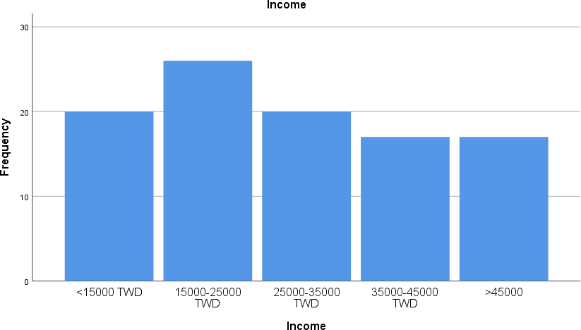
Figure 1: Income

As per the table and figure 1 the demographic information of income for the participants in the study is shown. The highest number of respondents for the income group was of 15000-25000 26.0% (N=366) and the least income of the respondent’s is >45000 17.0% (N=240).

Table 2: Work Experience
Work Experience
 |  | Frequency | Percent | Valid  Percent | Cumulative  Percent
Valid | 0-5 years | 390 | 27.0 | 27.0 | 27.0
Valid | 6-10 years | 471 | 33.0 | 33.0 | 60.0
Valid | 11-15 years | 348 | 26.0 | 26.0 | 86.0
Valid | >15 years | 198 | 14.0 | 14.0 | 100.0
Valid | Total | 1407 | 100.0 | 100.0

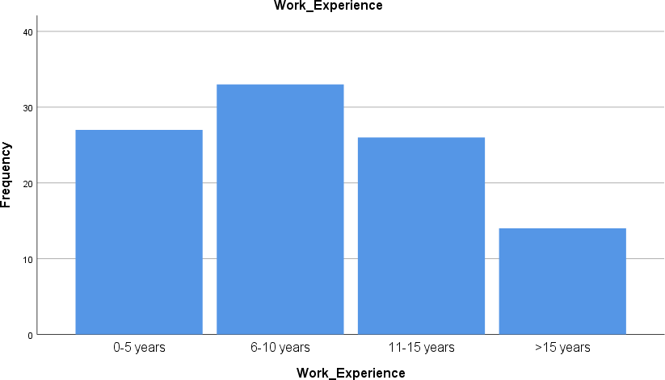
Figure 2: Work Experience

In the study data comprised of work experience from 0-5 years 27%, (N=390), 6-10 years 33% (N=471), 11-15 years 26% (N=348), and more than 15 years 26% (N=198). The detailed description of data is provided in Table 3.

Table 3: Technical Skill
Technical Skill
 |  | Frequency | Percent | Valid Percent | Cumulative Percent
Valid | Beginner | 418 | 30.0 | 30.0 | 30.0
 | Average | 361 | 26.0 | 26.0 | 56.0
 | Proficient | 361 | 25.0 | 25.0 | 81.0
 | Expert | 267 | 19.0 | 19.0 | 100.0
 | Total | 1407 | 100.0 | 100.0

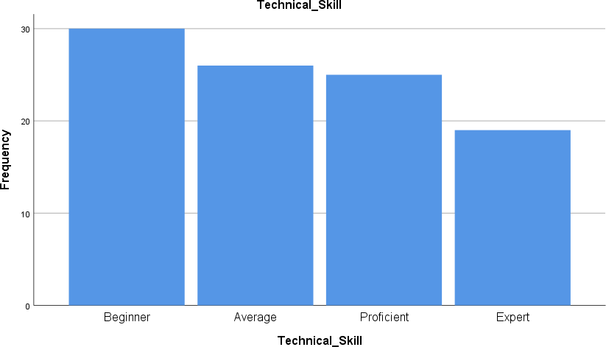
Figure 3: Technical Skill

In the study data comprised of technical skills of Beginner 30% (N=418), Average 26% (N=361), Proficient 25% (N=361), and Expert 19% (N=267). The detailed description of data is provided in Table 3.

4. Conclusion
According to the findings of the research, manufacturing companies in the nation need to concentrate their efforts on knowledge management in order to improve their level of product innovation. However, they need to place a greater emphasis on knowledge acquisition since the data showed that this aspect had a greater influence on product innovation than any of the other two aspects. The findings that knowledge management has a significant impact on product innovation suggest that product innovation could be improved through the appropriate acquisition, conversion, and application of knowledge in the manufacturing firms. This is indicated by the fact that the study found that knowledge management has a significant impact on product innovation. The gaining of new information may result in the introduction of novel concepts into the organisation by way of the newly recruited worker. These might result in the creation of novel goods via the conversion of the information that was gained. The proper implementation of this information improves the efficacy and efficiency of the manufacturing processes used by the companies. As a result, the conclusion that was reached was that effective knowledge management, which includes the collection, conversion, and application of information, has a constructive effect on the product innovation of manufacturing companies. Knowledge is increasingly seen as a key resource in all types of organisations in today's world. As a result, many businesses are looking into the possibility of using knowledge management in order to boost their overall organisational effectiveness. The favourable effects that knowledge management and certain of its methods have on the overall performance of organisations have been discussed in this article. Much research has come to the conclusion that KM is the primary cause for the expansion of businesses. Since KM resources and practices are connected to organisational performance improvement both directly resources and practices are connected to organisational performance improvement both directly
REFERENCES
- Serrat, W Chan, Hwang, Peter, & Burgers, Willem P. 2020. Multinationals’ diversification and the risk-return trade-off. Strategic Management Journal.
- Ferraresi, Jean-Jacques, & Martimort, David. 2021. The Theory of Incentives I: The Principal- Agent Model. Princeton, NJ: Princeton University Press. Lal, Rajiv, & Srinivasan, V. 1993. Compensation Plans for Single- and Multi-product Salesforces: An Application of the Holmstrom- Milgrom Model. Management Science.
- Abuabbous, Joseph, & Giachetti, Claudio. 2018. International diversification on manufacturing operations: Performance implications and moderating forces. Journal of Operations Management.
- Jacson, Christoph H., & Bode-Greuel, Kerstin. 2017. Evaluating growth options as sources of value for pharmaceutical research projects. R&D Management.
- Olusanva, Christoph H., & Kavadias, Stylianos. 2021. Implementing strategy through projects. Pages 225–251 of: Morirs, Peter W. G., Pinto, Jeffrey K., & Soderlund, Jonas (eds), The Oxford Handbook of Project Management. Oxford: Oxford University.
- Tseng, Christoph H., & Tapper, U.A. Steffan. 2020 Implementing a strategy-driven performance measurement system for an applied research group. Journal of Product Innovation Management.
- Hrebiniak, Christoph H., & Terwiesch, Christian. 2018. Handbook of New Product Development Management. Ch: Coordination and Information Exchange: Butterworth Heinemann.
- Drucker, Celine, & Llerena, Daniel. 2020. Green Consumer Behaviour: an Experimental Analysis of Willingness to Pay for Remanufactured Products. Business Strategy and the Environment.
- Saisuthanawit, Mark, & Krause, Daniel R. 2018. Re-exploring the relationship between flexibility and the external environment. Journal of Operations Management.
- Davenpork, Krishna. 2020. Diversification Strategy, Profit Performance, and the Entropy Measure. Strategic Management Journal, 6(3), 239–255.
- Lioria, Leslie E., Cardinal, Laura B., & Miller, C. Chet. 2018. Curvilinearity in teh Diversification-Performance Linkage: An Examination of Over Three Decades of Research. Strtategic Management Journal, 21(2), 155–174.
- Al-Ali, Cerag, Ferguson, Mark, & Toktay, L. Beril. 2018. Remanufacturing under Warranty and Consumer Returns. Working Paper.
- Branes, Dirk. 2020. Project Management for New Product Development. Project Management Journal.

